EXPT NO:6 | INTEGRATE DATA FROM VARIOUS SOURCES FOR COMPREHENSIVE ANALYSIS USING TABLEAU AND POWERBI
DATE: 24.07.2026

PRE-LAB QUESTIONS (PROVIDE BRIEF ANSWERS TO THE FOLLOWING QUESTIONS)

1. What is data integration in the context of Business Intelligence (BI)?
Data integration is the process of combining data from multiple sources, such as CSV files, Excel files, databases, and cloud services, into a single, unified dataset for analysis. It helps organizations create consistent reports, improve data accuracy, and gain comprehensive insights for better decision-making.

2. Explain the difference between a join and a data blend in Tableau.
A join combines two or more tables from the same or compatible data source into a single table based on a common field before analysis. It is performed at the data source level. A data blend, on the other hand, combines data from different data sources at the visualization level, where one source acts as the primary source and the other as the secondary source. Joins are generally more efficient when the data is stored in the same source, while data blending is useful when the data comes from different sources.

3. What are relationships and cardinality (e.g., one-to-many, many-to-many) in Power BI's data model?
Relationships in Power BI connect different tables using common columns so that data can be analyzed together. Cardinality defines how records in one table relate to records in another. Common types include one-to-one (1:1), one-to-many (1:*), and many-to-many (:). Choosing the correct relationship and cardinality ensures accurate filtering, calculations, and reporting across multiple datasets.

4. Why is data quality (e.g., consistent naming conventions, data types) crucial when integrating data from different sources?
Data quality is essential because inaccurate, inconsistent, or incomplete data can lead to incorrect analysis and poor business decisions. Consistent naming conventions, matching data types, and clean data ensure that relationships between tables are created correctly, calculations are accurate, and dashboard visualizations provide reliable insights.

5. Name two common challenges encountered during data integration.
Two common challenges encountered during data integration are:
- Inconsistent data formats and naming conventions, such as different region names or date formats across datasets, which can prevent proper relationships and analysis.
- Missing, duplicate, or inaccurate data, which can affect calculations, create incorrect visualizations, and reduce the reliability of business reports.

IN-LAB EXERCISE:
OBJECTIVE:
To connect to, combine, and model data from multiple disparate sources in Tableau and Power BI to create a unified, comprehensive dashboard for holistic analysis.

PROCEDURE:
- Data Collection:
  - Import data from at least two different sources (e.g., a CSV file and an Excel file).
  - Dataset 1: Sales Data (CSV file) with fields like Order ID, Order Date, Region, Sales Amount.
  - Dataset 2: Regional Sales Targets (Excel file) with fields like Region, Sales Target, Target Year.
- Data Preparation and Transformation:
  - Clean both datasets: Check for inconsistencies in region names (e.g., "N. America" vs. "North America").
  - Ensure data types are correct (e.g., Sales Amount is numeric, Order Date is a date).
  - Handle any missing values as appropriate.
- Data Integration and Modeling:
  - Tableau: Use the Data Source pane to establish a relationship or join between the Sales Data and Regional Targets tables using the common Region field.
  - Power BI: Use the Model view to create a relationship between the two tables, connecting them on the Region column. Define the cardinality (e.g., many-to-one).
- Create Calculated Fields for Comparison:
  - Develop new measures that leverage both datasets.

  - Examples: Target Achievement % = (SUM(Sales) / SUM(Sales Target)) * 100
  - Sales vs. Target Variance = SUM(Sales) - SUM(Sales Target)
- Design a Comprehensive Dashboard:
  - Create visuals that combine data from both sources to provide a single view of performance.
  - Add KPI cards for Total Sales and Overall Target Achievement %.
  - Use a gauge chart or bullet chart to show sales performance against targets for each region.
  - Create a combined bar chart showing Actual Sales vs. Target Sales by Region.
  - Use a map to visualize the Sales vs. Target Variance, highlighting underperforming or overperforming regions.
- Validate Data Integrity:
  - Verify that the joined/related data is accurate by cross-checking values.
  - Ensure filters on the dashboard correctly update visuals that use data from both sources.
- Publishing and Sharing:
  - Tableau: Publish the workbook to Tableau Public or Tableau Server.
  - Power BI: Publish the report to Power BI Service and share the link. Experiment Datasets:
Dataset 1: Retail Sales Data (CSV) Fields Used:
- Order ID – Unique identifier for each order
- Order Date – Date of the sales transaction
- Region – Sales region
- Sales – Sales revenue from the order
Dataset 2: Regional Sales Targets (Excel) Fields Used:
- Region – Sales region (used as the key for joining/relationship)
- Sales Target – The sales goal for the region
- Target Year – The year for which the target is set

Tableau:
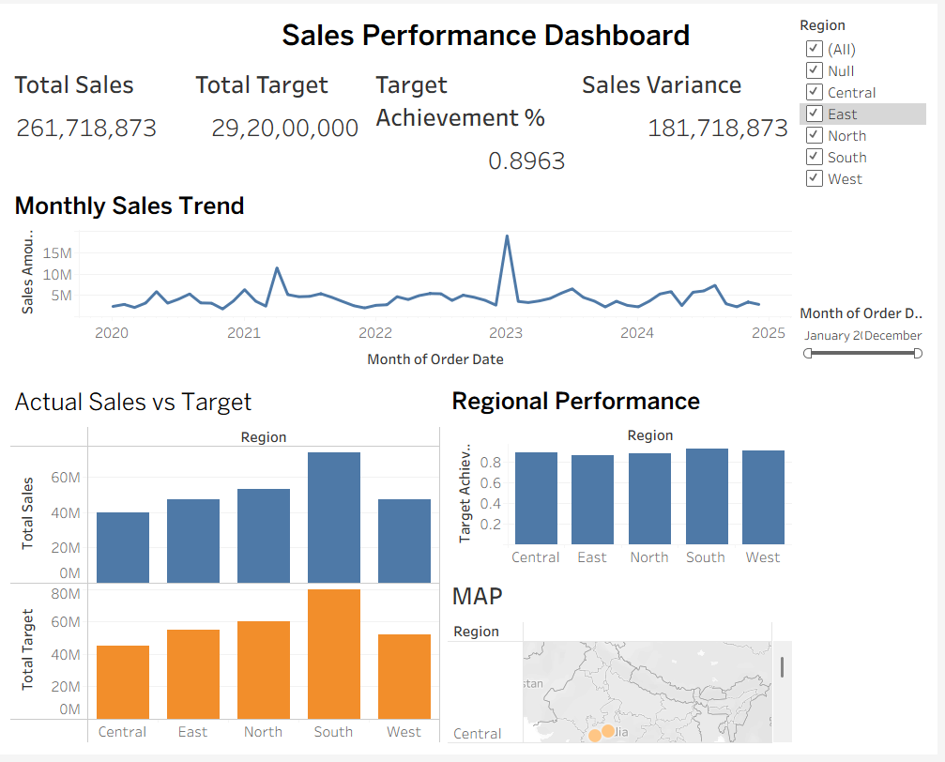

PowerBI:
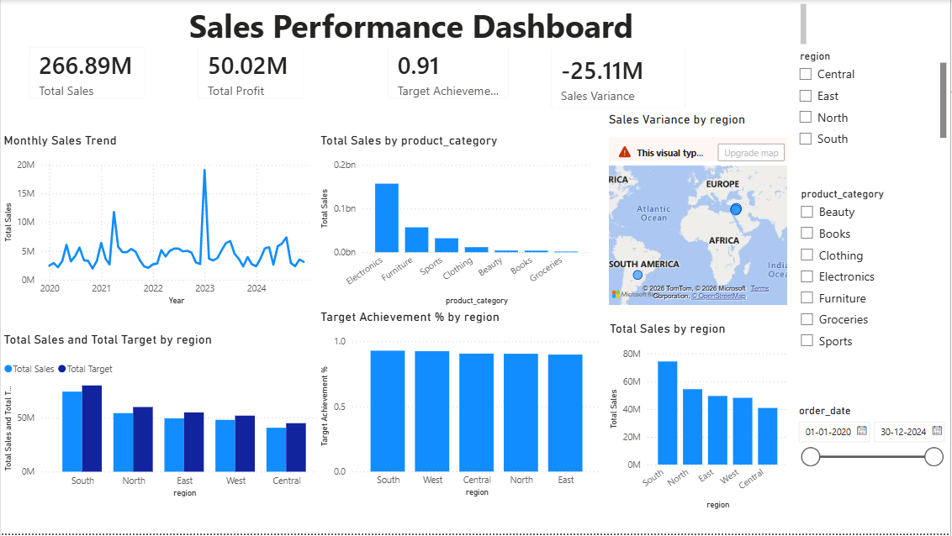

POST-LAB QUESTIONS (PROVIDE BRIEF ANSWERS TO THE FOLLOWING QUESTIONS)

1. How did integrating the sales targets data provide a more complete analytical picture than using the sales data alone?
Integrating the sales targets data with the actual sales data allowed for a direct comparison between planned performance and actual performance. It helped measure key business metrics such as target achievement percentage and sales variance, making it easier to identify regions that met or fell short of their sales goals. This provided a more comprehensive view of business performance than analyzing sales data alone.

2. Describe the type of join or relationship you used to combine the two datasets and explain why it was the appropriate choice.
A many-to-one relationship was created between the Retail Sales table and the Regional Sales Target table using the Region field as the common key. This was the appropriate choice because the sales dataset contained multiple transactions for each region, while the target dataset contained only one target value for each region. This relationship enabled accurate comparisons between actual sales and regional sales targets.

3. What challenges, if any, did you face regarding data granularity or mismatched keys (e.g., different region names) between the two sources?
One challenge was ensuring that the Region values were consistent in both datasets so that the relationship could be created correctly. It was also important to verify that there were no missing values or duplicate region names in the target dataset. Maintaining consistent data types and naming conventions helped avoid incorrect relationships and inaccurate calculations.

4. How can creating variance calculations (e.g., Sales vs. Target) help a business manager make better decisions?
Variance calculations help business managers quickly identify whether sales performance is above or below the planned targets. Positive variance indicates that sales have exceeded expectations, while negative variance highlights areas that require improvement. This information helps managers evaluate regional performance, allocate resources effectively, and make informed strategic decisions to improve future sales.

5. What other data source (e.g., marketing campaign data, customer demographics) could you integrate to further enrich this analysis, and what new insights might it provide?
Additional data sources such as marketing campaign data, customer demographics, or customer feedback could be integrated with the sales data. Marketing campaign data would help analyze the effectiveness of promotional activities on sales performance, while customer demographic data could reveal purchasing patterns across different customer groups. These insights would support better marketing strategies, customer targeting, and business planning.

RESULT:
The retail sales and regional targets datasets were successfully connected, cleaned, and integrated in both Tableau and Power BI. By creating relationships between the sources, a unified data model was built. The resulting comprehensive dashboard visualized sales performance against set targets, enabling variance analysis and providing deeper, context-rich insights into regional performance that were not possible with a single data source.

ASSESSMENT

Description | Max Marks | Marks Awarded
Pre Lab Exercise | 5
In Lab Exercise | 10
Post Lab Exercise | 5
Viva | 10
Total | 30
Faculty Signature

GITHUB Link: 24BAD045_BILab/EX6 at main · Jayasurya-C-0609/24BAD045_BILab

